# **Customer Care Work From Home (WFH) Personal Computer Setup**

Desktop Models

Dell 3050

HP 705

Dell 5080c Mini

HP 705 Mini

Lenovo ThinkCentre Mini

Related Documents

**Description**: Illustration and instructions to set up your personal computer when working from home.

|  |
| --- |
| **Desktop Models** |

CVS Health has several different models of desktops.

|  |  |  |  |  |  |
| --- | --- | --- | --- | --- | --- |
| **Types** | **Dell 3050** | **HP 705** | **Dell 5080c Mini** | **HP 705 Mini** | **Lenovo ThinkCentre Mini** |
| **Illustrations** |  |  |  |  |  |

Top of the Document

|  |
| --- |
| **Dell 3050** |

This section provides an illustration of this computer, the connections and how to set it up.

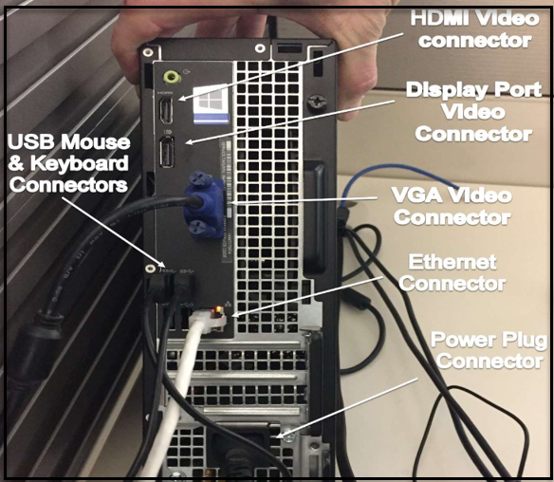

|  |  |
| --- | --- |
| **Step** | **Action** |
| **1** | Locate the VGA Video connector (back of computer) and take the monitor cables with connector(s) then insert and tighten (snug the adjustors on each side)   * If there is a second monitor, connect that cable into the Display Port Video connector. |
| **2** | Locate the USB connectors (back of computer) then insert the mouse and keyboard connectors |
| **3** | Locate the Ethernet connector and ensure that it is connected to your Wi-Fi modem then locate the Ethernet connector port (back of computer). Take the Ethernet connector and insert. |
| **4** | Locate the Power Plug Connector and insert the power cord connector then connect to an electrical outlet. |

Top of the Document

|  |
| --- |
| **HP 705** |

This section provides an illustration of this computer, the connections and how to set it up.

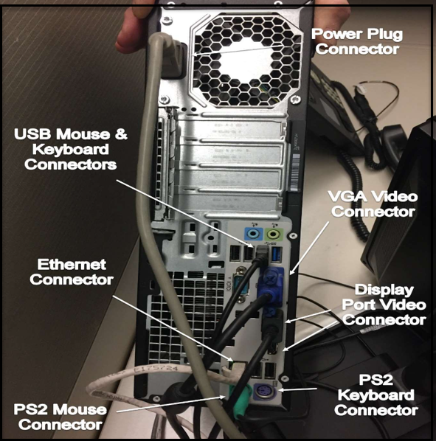

|  |  |
| --- | --- |
| **Step** | **Action** |
| **1** | Locate the VGA Video connector (back of computer) and take the first monitor cables with connector then insert and tighten (snug the adjustors on each side).   * If there is a second or third monitor, connect that cable into the Display Port Video connector. |
| **2** | Locate the USB connectors (back of computer) then insert the mouse and keyboard connectors.   * If you have a green PS2 mouse or a purple PS2 keyboard, they will get plugged into the PS2 mouse and PS2 keyboard connectors. |
| **3** | Locate the Ethernet connector and ensure that it is connected to your Wi-Fi modem then locate the Ethernet connector port (back of computer). Take the Ethernet connector and insert. |
| **4** | Locate the Power Plug Connector and insert the power cord connector then connect to an electrical outlet. |

Top of the Document

|  |
| --- |
| **Dell 5080c Mini** |

This section provides an illustration of this computer, the connections and how to set it up.

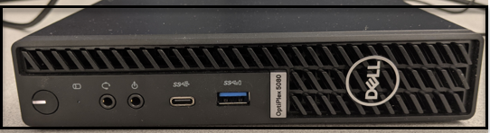

**Front of Computer**

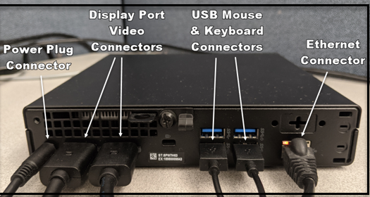

**Back of Computer**

|  |  |
| --- | --- |
| **Step** | **Action** |
| **1** | Locate the Display Port Video connector (back of computer) and take the first monitor cable with connector then plug into the connector.   * If there is a second monitor and cable, connect that cable into the Display Port Video connector. |
| **2** | Locate the USB connectors (back of computer) then insert the mouse and keyboard connectors. |
| **3** | Locate the Ethernet connector and ensure that it is connected to your Wi-Fi modem then locate the Ethernet connector port (back of computer). Take the Ethernet connector and insert. |
| **4** | Locate the Power Plug Connector and insert the power cord connector then connect to an electrical outlet. |

Top of the Document

|  |
| --- |
| **HP 705 Mini** |

This section provides an illustration of this computer, the connections and how to set it up.

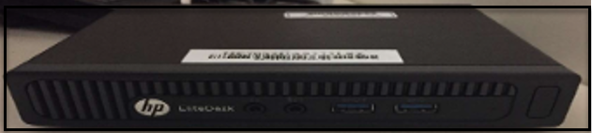

**Front of computer**

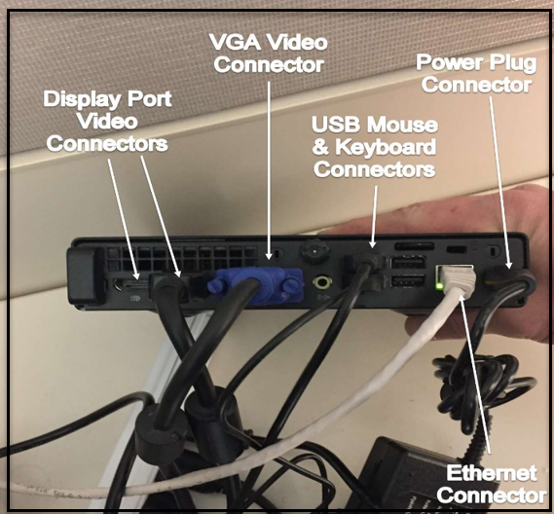

**Back of Computer**

|  |  |
| --- | --- |
| **Step** | **Action** |
| **1** | Locate the VGA Video connector (back of computer) and take the first monitor cables with connector then insert and tighten (snug the adjustors on each side).   * If there is a second or third monitor, connect that cable into the Display Port Video connector. |
| **2** | Locate the USB connectors (back of computer) then insert the mouse and keyboard connectors. |
| **3** | Locate the Ethernet connector and ensure that it is connected to your Wi-Fi modem then locate the Ethernet connector port (back of computer). Take the Ethernet connector and insert. |
| **4** | Locate the Power Plug Connector and insert the power cord connector then connect to an electrical outlet. |

Top of the Document

|  |
| --- |
| **Lenovo ThinkCentre Mini** |

This section provides an illustration of this computer, the connections and how to set it up.

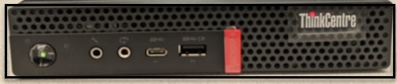

**Front of Computer**

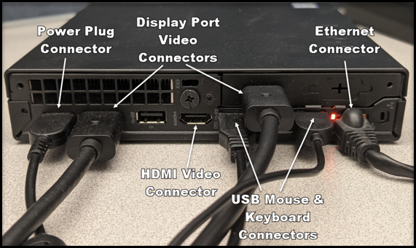

**Back of Computer**

|  |  |
| --- | --- |
| **Step** | **Action** |
| **1** | Locate the Display Port Video connector (back of computer) and take the first monitor cable with connector then plug into the connector.   * If there is a second monitor, connect that cable into the Display Port Video connector. |
| **2** | Locate the USB connectors (back of computer) then insert the mouse and keyboard connectors. |
| **3** | Locate the Ethernet connector and ensure that it is connected to your Wi-Fi modem then locate the Ethernet connector port (back of computer). Take the Ethernet connector and insert. |
| **4** | Locate the Power Plug Connector and insert the power cord connector then connect to an electrical outlet. |

Top of the Document

|  |
| --- |
| **Related Documents** |

Customer Care Abbreviations, Definitions, and Terms (017428)

**Parent Document:** [CALL 0049 Customer Care Internal and External Call Handling](https://policy.corp.cvscaremark.com/pnp/faces/DocRenderer?documentId=CALL-0049)

Top of the Document

Not to Be Reproduced or Disclosed to Others without Prior Written Approval

**ELECTRONIC DATA = OFFICIAL VERSION / PAPER COPY = INFORMATIONAL ONLY**